
Touchstones Project
Netcards

Awakening Netcards with Text

Asleep HRJ
Beauty HRJ
Birds HRJ
Book HRJ

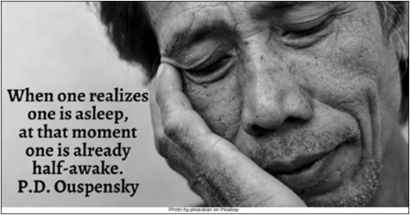

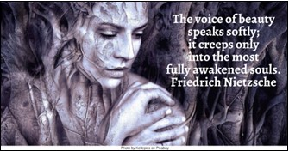

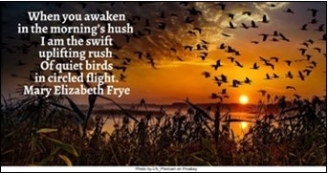



Buddha HRJ
Crowd HRJ
Dance HRJ
Empty Bowl HRJ

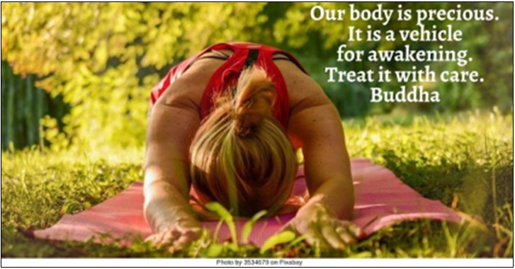

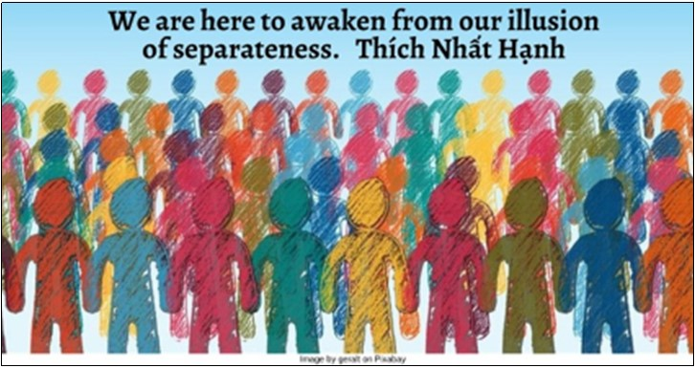

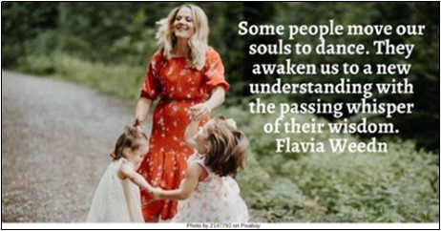

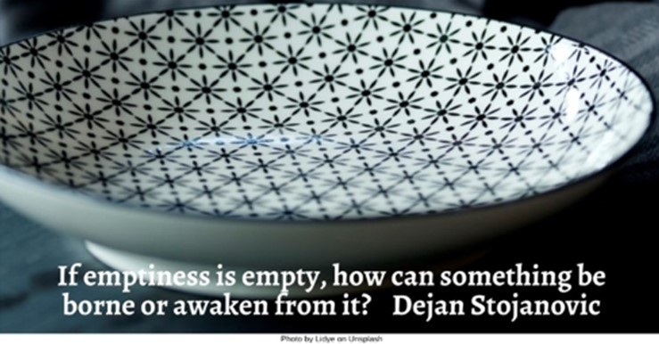

Eyes Open HRJ
Fire HRJ
Flying Bird HRJ
Grave HRJ

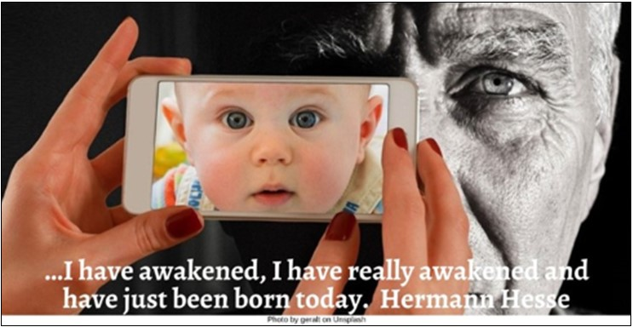

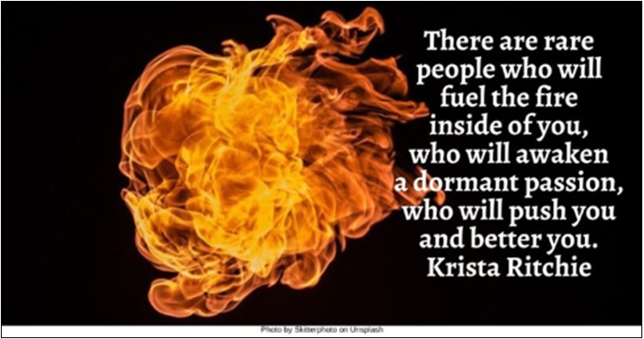

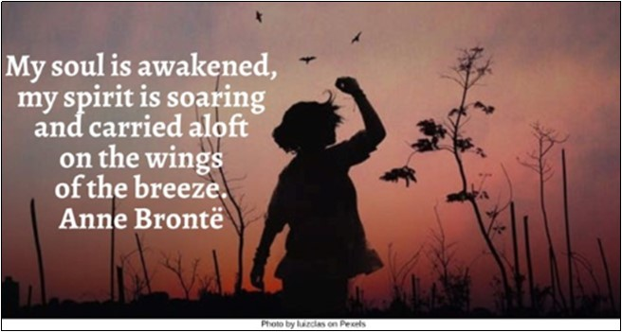

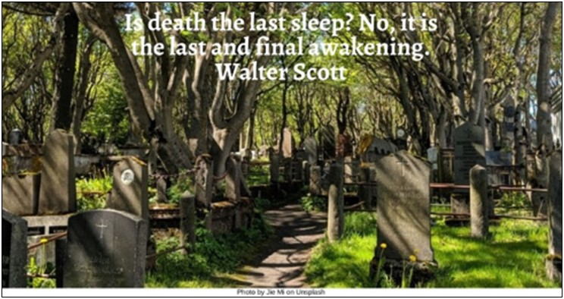

Happiness HRJ
Lotus Flower HRJ
Love HRJ
Meditation HRJ

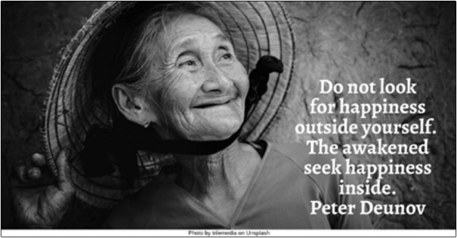

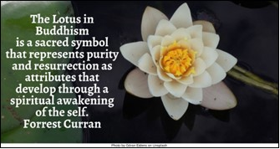

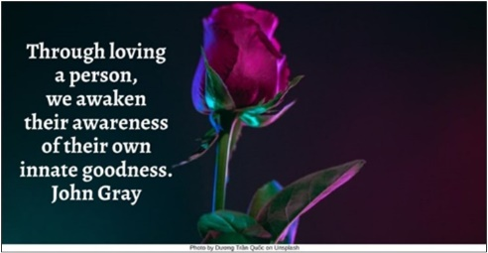

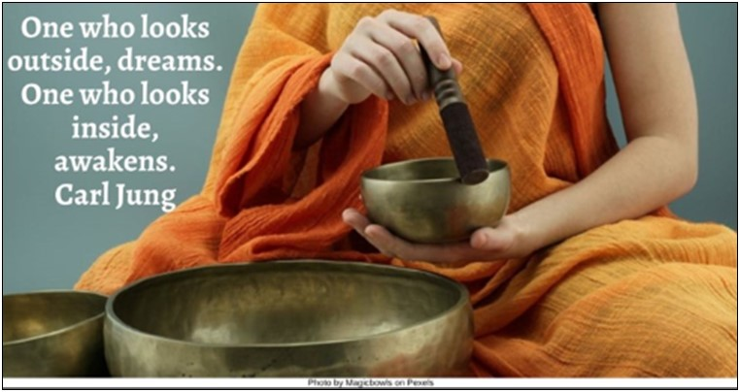

Morning HRJ
Old Person HRJ
Rain HRJ
Reproductive Rights HRJ

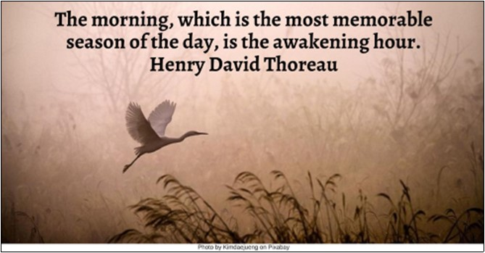

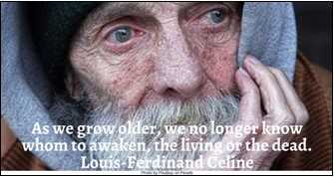

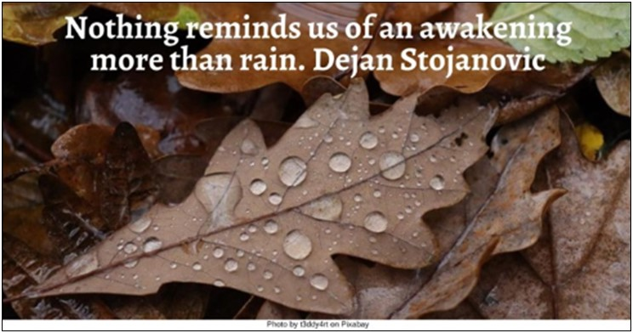



Road HRJ
Seeing HRJ
Silence HRJ
Sleeping HRJ

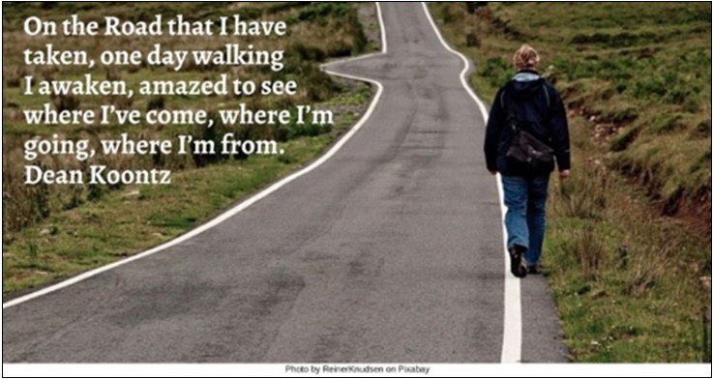

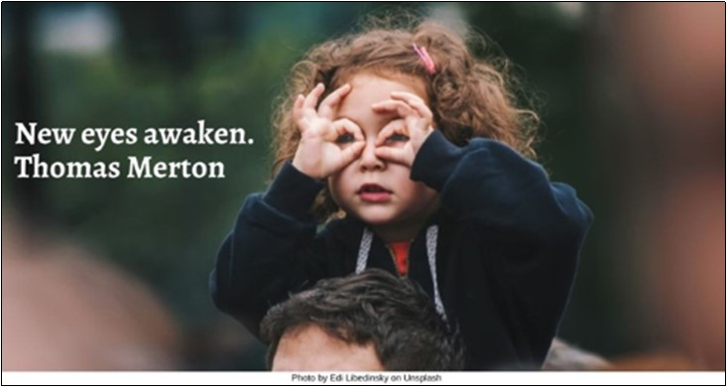

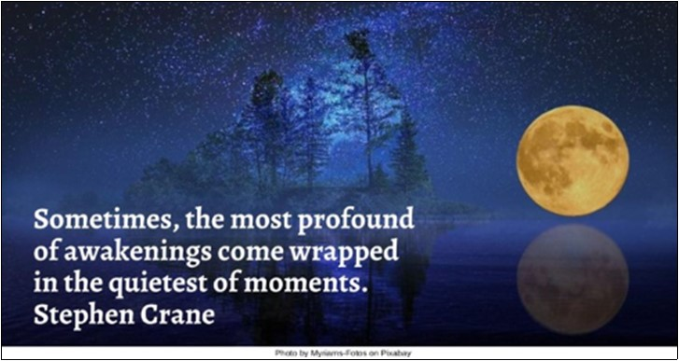

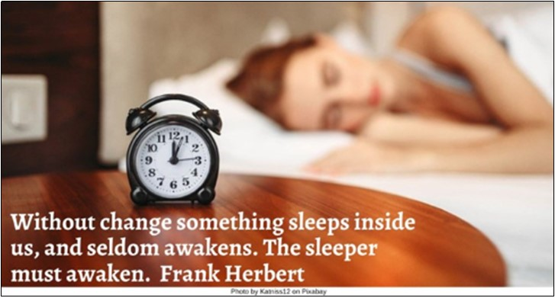

Smile HRJ
Solitude HRJ
Sorrow HRJ
Spirit Dance HRJ

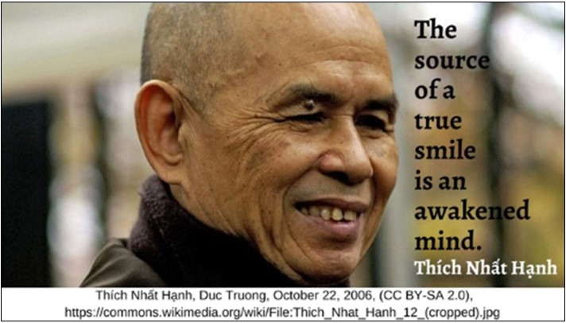

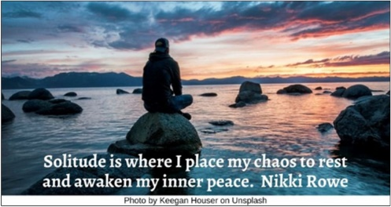

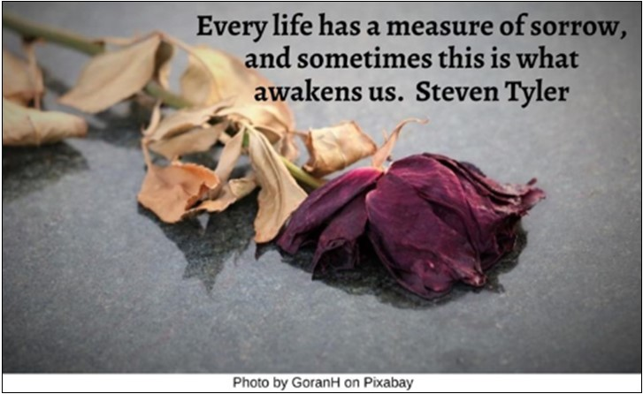

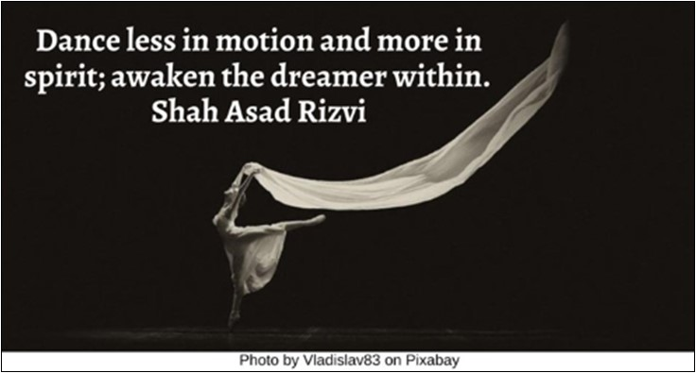

Teacher HRJ
Waves HRJ
Woman sitting alone HRJ

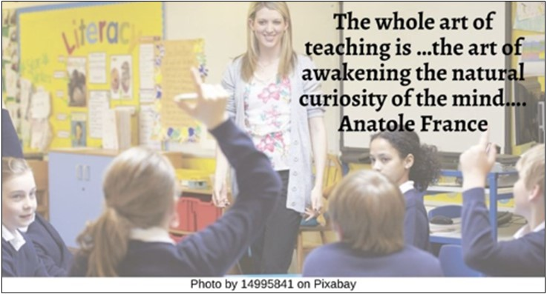

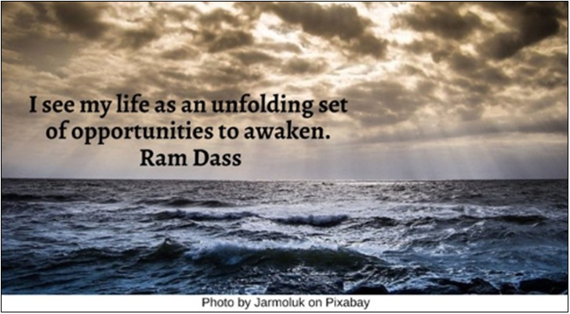



Text of Quotes
Asleep HRJ
When one realizes one is asleep, at that moment one is already half-awake. P.D. Ouspensky

Beauty HRJ
The voice of beauty speaks softly; it creeps only into the most fully awakened souls. Friedrich Nietzsche

Birds HRJ
When you awaken in the morning’s hush / I am the swift uplifting rush / Of quiet birds in circled flight. Mary Elizabeth Frye

Book HRJ
An outstanding book always surprises you and awakens you to new ideas, new ways of looking at the world…. Brittainy Cherry

Buddha HRJ
Our body is precious. It is a vehicle for awakening. Treat it with care. Buddha

Crowd HRJ
We are here to awaken from our illusion of separateness. Thích Nhất Hạnh

Dance HRJ
Some people move our souls to dance. They awaken us to a new understanding with the passing whisper of their wisdom. Flavia Weedn

Empty Bowl HRJ
If emptiness is empty, how can something be borne or awaken from it? Dejan Stojanovic

Eyes Open HRJ
…I have awakened, I have really awakened and have just been born today. Hermann Hesse

Fire HRJ
There are rare people who will fuel the fire inside of you, who will awaken a dormant passion, who will push you and better you. Krista Ritchie

Flying Birds HRJ
My soul is awakened, my spirit is soaring and carried aloft on the wings of the breeze. Anne Brontë

Grave HRJ
Is death the last sleep? No, it is the last and final awakening. Walter Scott

Happiness HRJ
Do not look for happiness outside yourself. The awakened seek happiness inside. Peter Deunov

Lotus Flower HRJ
The Lotus in Buddhism is a sacred symbol that represents purity and resurrection as attributes that develop through a spiritual awakening of the self. Forrest Curran

Love HRJ
Through loving a person, we awaken their awareness of their own innate goodness. John Gray

Meditation HRJ
One who looks outside, dreams. One who looks inside, awakens. Carl Jung

Morning HRJ
The morning, which is the most memorable season of the day, is the awakening hour. Henry David Thoreau
Photo by Kimdaejueng on Pixabay

Old Person HRJ
As we grow older, we no longer know whom to awaken, the living or the dead. Louis-Ferdinand Celine
Photo by Pixabay on Pexels
Rain HRJ
Nothing reminds us of an awakening more than rain. Dejan Stojanovic

Reproductive Rights HRJ
Only collective awakening can create enough determination for action. Thích Nhất Hạnh

Road HRJ
On the Road that I have taken, one day walking I awaken, amazed to see where I’ve come, where I’m going, where I’m from. Dean Koontz

Seeing HRJ
New eyes awaken. Thomas Merton

Silence HRJ
Sometimes, the most profound of awakenings come wrapped in the quietest of moments. Stephen Crane
Photo by Myriams-Fotos on Pixabay

Sleeping HRJ
Without change something sleeps inside us, and seldom awakens. The sleeper must awaken. Frank Herbert
Photo by Katniss12 on Pixabay

Smile HRJ
The source of a true smile is an awakened mind. Thích Nhất Hạnh

Solitude HRJ
Solitude is where I place my chaos to rest and awaken my inner peace. Nikki Rowe

Sorrow HRJ
Every life has a measure of sorrow, and sometimes this is what awakens us. Steven Tyler

Spirit Dance HRJ
Dance less in motion and more in spirit; awaken the dreamer within. Shah Asad Rizvi

Teacher HRJ
The whole art of teaching is …the art of awakening the natural curiosity of the mind…. Anatole France

Waves HRJ
I see my life as an unfolding set of opportunities to awaken. Ram Dass

Woman sitting alone HRJ
She was becoming herself and daily casting aside that fictitious …garment with which to appear before the world. Kate Chopin

